**Lab # 02**

**Objective: To become familiar with Stream Socket API.**

**Task 1: Compile and run the above code. Start the acceptor first and then the requestor with appropriate command line arguments. Describe and explain the output.**

**Code:**

**Acceptor:**

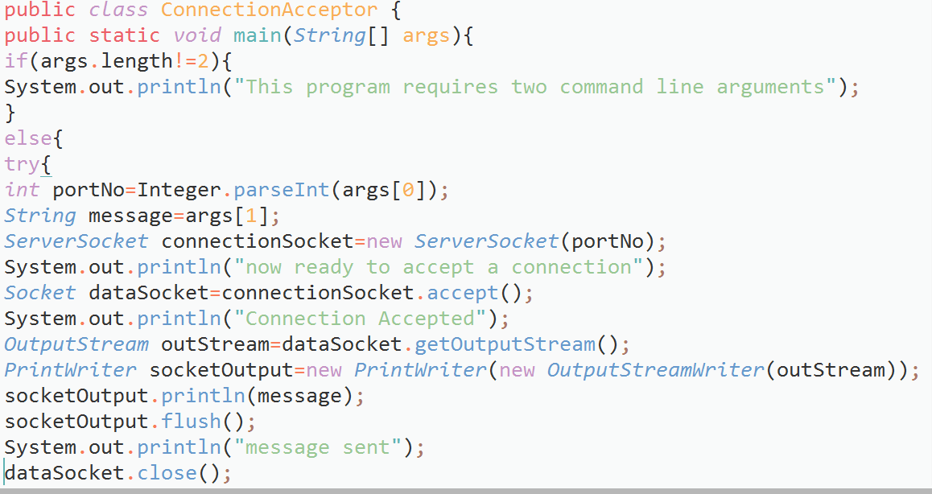

**Requestor:**

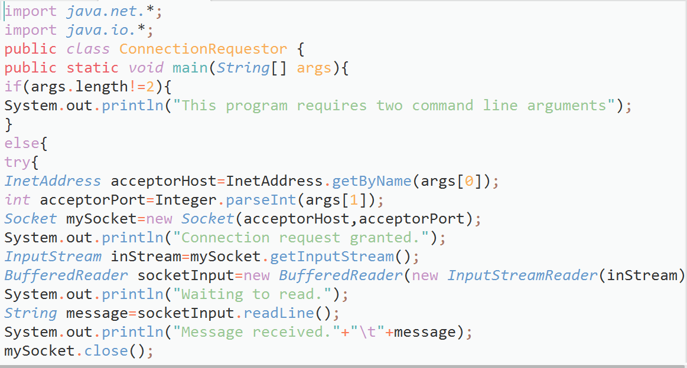

**Output:**

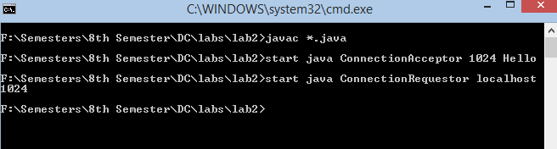

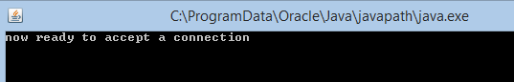

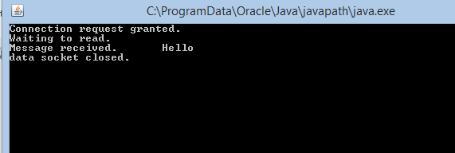

**Task2: Now run the code again, but reverse the order of program’s execution. Start the requestor first and then the acceptor. Describe and explain the outcome.**

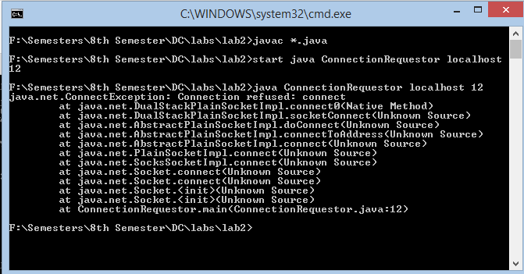

**Task 3: Add a time delay of 5 seconds in the ConnectionAcceptor process just before the message is written to the socket, then run the program. This will show you the blocking at the receiver. Show a trace of the output of the processes.**

